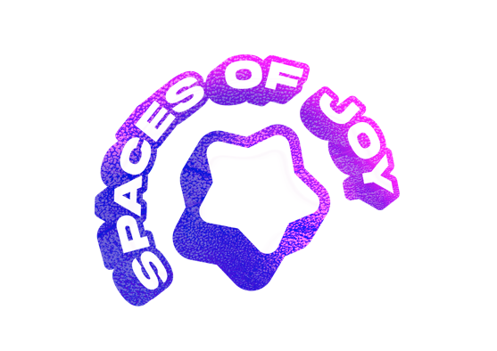
SPACES OF JOY

Callout for Learning Disabled & Neurodivergent (LD/ND) artists creating performance work.

Spaces of Joy is a nationwide 12-week pilot programme for 12 producers of contemporary performance, equipping them with the knowledge, skills, resources and networks for working with and being closer to the creative practice of Learning Disabled and Neurodivergent (LD/ND) artists.

As part of our programme, we are looking for learning disabled & neurodivergent (LD/ND) performers and performance artists to work closely with us to ensure that our programme has LD/ND performers and performance artists at its heart.

ARTISTS

The guiding aim of the programme is to establish more links between producers, artists and venues to ensure that more Learning Disabled and Neurodivergent artists are having their creative work produced. We want to broker fruitful collaborations that are set up with processes of care and access at the forefront.

We want to build an artist network of LD/ND artists looking to meet producers and will facilitate meetings, chances to come see your work and invitations to events.

Are you interested in:

- Sharing your experiences with the chosen 12 Spaces of Joy producers
- Attending the producer workshops to help shape their learning
- Being part of a network of other ND/LD artists working nationally
- Getting your work seen by producers who may wish to collaborate with you in the future
- Meeting producers interested in LD/ND led work
- Having access to the resources and materials created on the programme

Then send us your details to be added to our network and mailing list so that we can get in touch.

Please answer the questions below, and email these to us programme@the-hale.com

If you have any questions please email Daisy Hale daisy@the-hale.com

You can answer via video or audio if this is preferable to you.

- Your name, address including postcode, and phone number
- A short overview of your creative work (max 250 words, or 3 min voice/video recording) covering
- your performance background
- your achievements
- areas of particular interest and focus
- A link to your website or social medias (if applicable)
- Any performances you have coming up with dates, location and if available, booking link.

